**ACG Project**

* CodePipeline
* CodeBuild
* S3

**Continuous Deployment**

* Automation of new features or code into a testing or production environment
* No manual builds
* Immediately available
* Agile
* CI/CD toolchain

**Architecture**

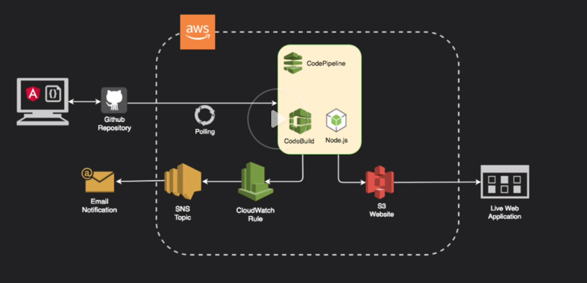

Store the code in Github, which will then integrate directly into CodePipeline. CodePipeline then uses polling to check for any new changes from Github and begins it’s release process if any new changes are detected. In the CodePipeline, CodeBuild is used to build and package the code using a node.js runtime and then deploy the packaged code to S3 where it can be viewed using static web hosting. Then a CloudWatch Rule can be set in the CodePipeline to trigger a SNS notification to send an email.

1. Integrate Github with CodePipeline
2. Upload code to Github
3. CodePipeline polls Github
4. CodeBuild builds and packages the code using a node.js runtime
5. Packaged code is deployed to S3
6. CloudWatch Rule can be set to trigger SNS notifcations

**CodePipeline**

**Requires:**

* **Pipeline Settings**   
  - Name - cannot change after creation  
  - Service Role (ARN or new)  
  - S3 Bucket  
  - Encryption Key (Default or Customer)
* **Source Stage**- Github, S3, ECR, CodeCommit  
  - Repo  
  - Branch  
  - Github Webhooks/CodePipeline Polling
* **Build Stage**  
  - **Build Provider** (CodeBuild/Jenkins)  
  - Region  
  - Project Name  
  - Env Variables
* **Deploy Stage**  
  - **Deploy Providers**  
  - CloudFormation  
  - CodeDeploy  
  - Elastic Beanstalk  
  - Service Catalog  
  - ECS  
  - ECS Blue/Green  
  - S3

Creates a S3 bucket to store the artifacts from the build